**SQL Server Mirroring**

SQL Server Mirroring is a disaster recovery and high availability technique that involve two SQL Server on the same or different machine. One SQL Server instance acts as a primary instance called the **principal**, while other is a mirrored instance called the **mirror**. In special case there can be a third SQL Server instance that acts as a witness.

Database mirroring is a solution for increasing the availability of a SQL server database. It works when the database is in full recovery model.

Transaction log records are sent directly from the principal database to the mirror database. This helps to keep the mirror database up to date with the principal database, with no loss of committed data.

If the **principal server fails**, the mirror server automatically becomes the **new principal server** and recovers the principal database using a witness server user high-availability mode.

Database mirroring maintains two copies of a single database that must reside on different server instance of SQL Server Database Engine. Typically, these server instance reside on computers in different locations.

One Server instance serves the database to the client (the principal server). The other instance act as a hot or warm standby server (the mirror server)

***Note:*** *Transaction is a unit of work that is performed against a database. Transaction are units or sequence of work accomplished in logical order, whether in a manual way by a user or automatically by some sort of a database program. Transaction keywords: commit, rollback, savepoint, Set transaction.*

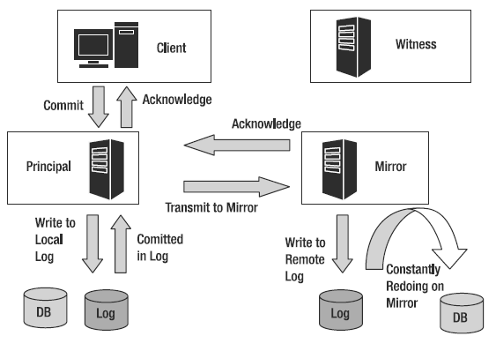

**Prerequisites**

1. The Database must be full recovery model.
2. Database name should be same on both SQL Server instances.
3. A full database and transaction log backups of the database which will be mirrored must be created and restored on the SQL Server instance which will act as the mirror. The restore process must be executed using the WITH NORECOVERY option.
4. The Endpoints must be correctly configured: Make sure that each server instance (the principal server, mirror server, and witness server, if any) has a database endpoint.

͢ (An endpoint is a network protocol which is used to communicate Principal, Mirror, Witness servers on the network)

**Terminology**

**Principal Server:**

In Database mirroring, the partner whose database is currently the principal database.

**Principal Database:**

In Database mirroring, a read-write database whose transaction log records are applied to a read-only copy of the database (a mirror database).

**Mirror server:**

In a database mirroring configuration, the server instance on which the mirror database resides.

**Mirror Database:**

The copy of the database that is typically fully synchronized with the principal database.

**Manual Failover:**

A failover initiated by the database owner, while the principal server is still running, that transfers service from the principal database to the mirror database while they are in a synchronized state.

**Automatic Failover:**

The process by which, when the principal server becomes unavailable, the mirror server to take over the role of principal server and bring its copy of the database online as the principal database.

**Operation mode**

There are thee operation modes.

1. High safety or High protection mode
2. High performance
3. High safety with witness or High availability mode.

**High safety or High protection:**

* Data is written and committed on the principal and mirror databases synchronously. Only after committing on both databases, the database application can continue with activity.
* There might be a delay and slower operation because transaction must be committed on both databases.
* It has transactional safety FULL i.e., synchronous communication between principal and mirror.

**High Performance:**

* Data is written and committed on the principal server then sent and committed to the mirror server in asynchronous mode.
* If the principal server goes down, there are three options:

1. Do nothing – wait for the principal server becomes available again. Mirror server will continue where it has stopped.
2. Force the SQL server instance on the mirror database - the mirror database becomes principal server. Greater possibility for data loss, due to asynchronous communication.
3. Manual update- to reduce data loss, take the tail of the log backup if the failed server allows, remove mirroring and restore the tail of the log on the previous mirrored database.

**High safety with witness:**

* Data backup will save in third server which is witness server.
* Witness server is an optional option and is not necessary for all Database Mirroring.
* In failure some data will save in witness server.

**Advantages of Database Mirroring**

1. Minimizes data loss
2. Provides a high availability of database
3. It has automatic server failover and client failover mechanism.
4. Database Mirroring does not require special hardware.
5. Lower infrastructure cost.
6. Configuration is simpler than Log shipping and replication.
7. Database Mirroring is more robust than and efficient than Log shipping.

**Disadvantage of Database Mirroring**

1. Data loss is possible, if it is in asynchronous operation mode. (High Performance mode)
2. User operation is not possible in the mirror server/database. It’s only works at database level and not at server level.
3. SQL server mirroring is possible only in full recovery mode.
4. Late delay possibilities can occur during data transfer.
5. Delay possibilities can be prevented with good hardware.

It is clear that the database mirroring in SQL Server plays an important role. It minimizes the data loss chance in SQL Server. Moreover, a high availability of database. It also helps in case of corruption of principal database and the mirror database take place of principal database and is used as a principal database.

**How to Mirror SQL Server?**

The database mirroring feature is available in SQL Server 2005 version and greater. Availability of the operating modes depends on the SQL Server edition. Different SQL Server versions can be combined, but it’s not recommended.

The database that needs to be mirrored must be in the full recovery model. System databases can’t be mirrored.

A full database and transaction log backups of the database which will be mirrored must be created and restored on the SQL Server instance which will act as the mirror. The restore process must be executed using the WITH NORECOVERY option

The database mirroring setup needs to be initiated from the principal server using the SQL Server Management Studio wizard or T-SQL code. At the beginning of the setup process, there’s an option for choosing a witness SQL Server instance which is only required if the high safety with automatic failover mode is desired. SQL Server instances must be able to communicate which requires creation of so-called endpoints with the port and name specified. These setting are required both on the principal and mirror SQL Server instances.

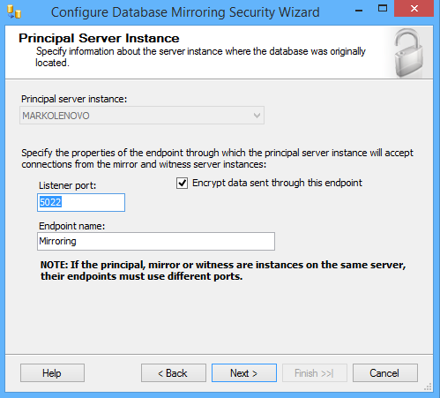

After endpoints are created and connection checked, select the operating mode, either high safety or high performance. If the witness server is specified choosing high safety mode will result in high safety with automatic failover.

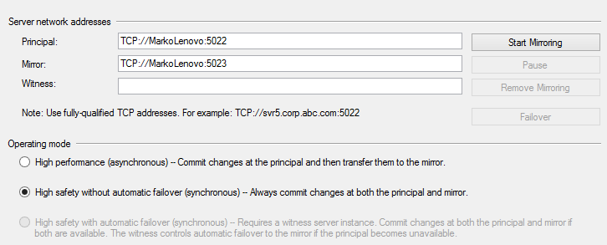

* Please see the ref.1 video for Mirror configuration.
* (Setting up the database mirroring environment) in Ref.3 Link.
* (Configuring Synchronous SQL Server Database Mirroring) in Ref.10
* SQL server config for Mirroring in Ref.14, 15

***SQL Server Mirroring will be removed in future version of MSSQL***

Ref:

1. <https://www.youtube.com/watch?v=DlukbLQCkZ0>
2. <https://www.c-sharpcorner.com/UploadFile/nipuntomar/sql-server-database-mirroring-part-1/>
3. <https://www.sqlshack.com/sql-server-database-mirroring/>
4. <https://www.tatvasoft.com/blog/how-to-configure-database-mirroring-for-sql-server/>
5. <https://www.sqlserverlogexplorer.com/database-mirroring-in-sql-server/#>
6. <http://sql-articles.com/articles/high-availability/advantages-a-disadvantages-of-database-mirroring/>
7. <https://www.sqlserverlogexplorer.com/database-mirroring-in-sql-server/#>
8. <http://sqlanddotnetdevelopment.blogspot.com/2012/02/advantage-and-disadvantage-of-database.html>
9. <https://docs.microsoft.com/en-us/sql/database-engine/database-mirroring/database-mirroring-sql-server?view=sql-server-ver15>
10. <https://www.mssqltips.com/sqlservertip/6953/configure-database-mirroring-t-sql-code/>
11. <https://www.youtube.com/watch?v=C_npQPAI1Yo>
12. <https://www.youtube.com/watch?v=M0sQay6qwJ4>
13. <https://www.mssqltips.com/sqlservertip/2464/configure-sql-server-database-mirroring-using-ssms/>
14. <https://www.sqlservercentral.com/blogs/configure-sql-server-database-mirroring-step-by-step>
15. https://dh2i.com/blog/how-to-configure-database-mirroring-for-sql-server-2/